Use DQL statements to print the details of employees to give the following output:
- “Name of employee work in deptno with the job_Id” use last_name coloum
select last_name,department_id as work_in_dept_no,job_id as with_the_jobid from employees;


- Employees who joined in the year 2000
select last_name from employees where date_format(hire_date,'%Y')=2000;


- Emploees who joined in after jan_1996
select last_name from employees where date_format(hire_date,'%M %Y')>'jan 1996';

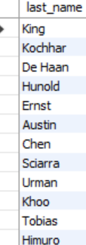

- Employess whose name starts between ‘S’ to ‘R’
select last_name from employees where last_name like "s%" or last_name like "r%";
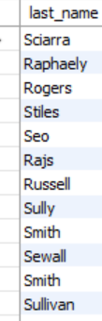

- Employees who works under manger_id (200,201)
select first_name,last_name from employees where (manager_id=200 or manager_id=201);

- Employees who are “REP”(representatives) or “MAN”(salesmans) and who are paid more than 6000
select first_name,last_name from employees where ((job_id like "%rep%") or (job_id like "%man%")) and salary>6000;
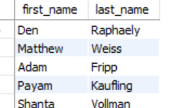
- Calculate annual salary of each employee and print them in descending order
select last_name,salary*12 from employees order by salary desc;
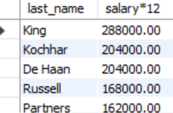
- Replace the last_name of “Landry” to “JOE” in the employee table

select last_name,replace(last_name,'landry','joe') from employees where last_name='landry';

- Find the position of first occurance of the character ‘o’ in the last_name of all employees who have ‘o’ in their last_name.
select last_name ,locate('o',last_name) from employees;
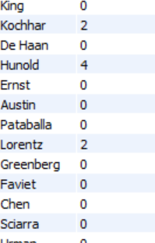

- Prefix “2020_B84” for employee last_names who works in department 90
select concat("2020_B84",last_name) names from employees where department_id=90;



- Find the current date with local date and time

select now();



- Find the average commission paid for all the employees (ignoring the null entries)

select avg(commission_pct) from employees;
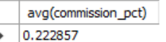

- Find the average and highest salary paid for department 80,90,100
select department_id,avg(salary),max(salary) from employees group by department_id having department_id in(80,90,100);

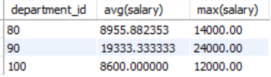

- Find the department id where the highest paid employee salary is more than 1000.
select department_id from employees group by department_id having max(salary)>1000;

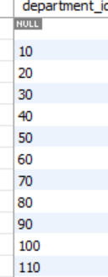

- Find the department id who is paid the maximum average salary in the organization: use subqueries

select department_id from employees group by department_id having avg(salary)>=(select max(sal) from (select avg(salary) sal,department_id from employees group by department_id)as m);



- Find the departmentname and loacation_id in which ‘Ernst’ work.
select d.department_name,d.location_id from departments d inner join employees e on last_name='ernst' and d.department_id=e.department_id;



- Find all the employee names who work in “Tokyo” city ( use subqueries , table used : employees, departments, locations )

Select e.first_name from employees e where department_id=(select d.department_id from departments d inner join locations l on l.location_id=d.location_id where l.city=’tokyo’);

- Find the employee names who are the maximum paid salary in the organization
select last_name from employees where salary=(select max(salary) from employees);


- Find the employees who are drawing minimum salary in their respective departments
(Use the jobs table for getting the min salary and use subquries )

select last_name,department_id from employees where salary in (select min_salary from jobs) group by department_id;

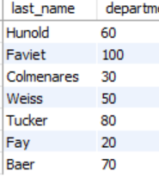

- Find the employee names and their job_id and job_titles by joining employee and jobs table

select e.last_name,e.job_id,j.job_title from employees e inner join jobs j where e.job_id=j.job_id;

